# Exercises: Objects and Classes

Problems for exercises and homework for the [“Programming Fundamentals” course @ SoftUni](https://softuni.bg/courses/programming-fundamentals).

You can check your solutions here: <https://judge.softuni.bg/Contests/210/Objects-and-Classes-Exercises>.

## Count Working Days

Write a program that **reads two dates** in formatdd-MM-yyyy and prints the **number of working days** between these two dates **inclusive**. Non-working days are:

* All days that are **Saturday** or **Sunday**.
* All days that are **official holidays** in Bulgaria:
  + New Year Eve (**1 Jan**)
  + Liberation Day (**3 March**)
  + Worker’s day (**1 May**)
  + Saint George’s Day (**6 May**)
  + Saints Cyril and Methodius Day (**24 May**)
  + Unification Day (**6 Sept**)
  + Independence Day (**22 Sept**)
  + National Awakening Day (**1 Nov**)
  + Christmas (**24**, **25** and **26 Dec**)

All days not mentioned above are **working** and should count.

### Examples

|  |  |
| --- | --- |
| **Input** | **Output** |
| 11-04-2016  14-04-2016 | 4 |
| 11-04-2016  22-04-2016 | 10 |
| 20-12-2015  31-12-2015 | 7 |

### Hints

* Read **start date** and **end date** from Console.
* **Create** two objects of type DateTime – startDate and endDate.
* Create an **array of type** DateTime and add **all official holidays** in it.
* Loop from startDate to endDate. Add **1 day** at each iteration.
* Get the **current da**y in the loop and check whether is **Saturday**, **Sunday** or it is **contained** **in the holidays array**. If it is not, increment the workingDaysCounter.

## Advertisement Message

Write a program that **generate random fake advertisement message** to extol some product. The messages must consist of 4 parts: laudatory **phrase** + **event** + **author** + **city**. Use the following predefined parts:

* **Phrases** – {“Excellent product.”, “Such a great product.”, “I always use that product.”, “Best product of its category.”, “Exceptional product.”, “I can’t live without this product.”}
* **Events** – {“Now I feel good.”, “I have succeeded with this product.”, “Makes miracles. I am happy of the results!”, “I cannot believe but now I feel awesome.”, ”Try it yourself, I am very satisfied.”, “I feel great!”}
* **Author** – {“Diana”, “Petya”, “Stella”, “Elena”, “Katya”, “Iva”, “Annie”, “Eva”}
* **Cities** – {“Burgas”, “Sofia”, “Plovdiv”, “Varna”, “Ruse”}

The format of the output message is: **{phrase} {event} {author} – {city}**.

As an input you take the **number of messages** to be generated. Print each random message at a separate line.

### Examples

|  |  |
| --- | --- |
| **Input** | **Output** |
| 3 | Such a great product. Now I feel good. Elena – Ruse  Excelent product. Makes miracles. I am happy of the results! Katya – Varna  Best product of its category. That makes miracles. Eva - Sofia |

### Hints

* Hold the phrases, events, authors and towns in 4 arrays of strings.
* Create Random object and **generate** **4 random numbers** each in its range:
  + phraseIndex 🡪 ­[0, phrases.Length)
  + eventIndex 🡪 [0, events.Length)
  + authorIndex 🡪 [0, authors.Length)
  + townIndex 🡪 [0, towns.Length)
* Get one **random element** from each of the four arrays and **compose a message** in the required format.

## Intersection of Circles

Create class Circle with properties Center and Radius. The center is a point with coordinates X and Y (make a class Point). Write a method bool Intersect(Circle c1, Circle c2) that tells whether the two given circles **intersect or not**. Write a program that tells if two circles intersect.

The input lines will be in format: **{X} {Y} {Radius}**. Print as output “Yes” or “No”.

### Examples

|  |  |  |
| --- | --- | --- |
| **Input** | **Output** | **Visualization** |
| 4 4 2  8 8 1 | No |  |
| 3 3 2  4 3 6 | Yes |  |
| 1 1 4  4 2 5 | Yes |  |

### Hints

* Calculate d = **distance between the circle centers**.
* If the d ≤ r1 + r2 (the sum of radiuses**) 🡪** the circles **intersect** (or one of the circles is inside the other or the circles have one common point when d = r1 + r2).
* If the d > r1 + r2 **🡪** the circles do **not intersect** (they have not common shared point).

## Average Grades

Define a class Student, which holds the following information about students: **name**, **list of grades** and **average grade** (calculated property, read-only). A single grade will be in range [2…6], e.g. 3.25 or 5.50.

Read a **list of students** and print the students that have **average grade ≥ 5.00** ordered **by name** (ascending), then by **average** **grade** (descending). Print the student name and the calculated average grade.

### Examples

|  |  |
| --- | --- |
| **Input** | **Output** |
| 3  Ivan 3  Todor 5 5 6  Diana 6 5.50 | Diana -> 5.75  Todor -> 5.33 |
| 6  Petar 3 5 4 3 2 5 6 2 6  Mitko 6 6 5 6 5 6  Gosho 6 6 6 6 6 6  Ani 6 5 6 5 6 5 6 5  Iva 4 5 4 3 4 5 2 2 4  Ani 5.50 5.25 6.00 | Ani -> 5.58  Ani -> 5.50  Gosho -> 6.00  Mitko -> 5.67 |

### Hints

* Create class Student with properties Name (string), Grades (double[]), and property AverageGrade (calculated by LINQ as Grades.Average(), read-only).
* Make a **list of students** and **filter with LINQ** all students that has average grade >= 5.00.
* Print the filtered students **ordered by name** in ascending order, then by **average grade** in descending order.

## Book Library

To model a **book library**, define classes to hold a **book** and a **library**. The library must have a **name** and a **list of books**. The books must contain the **title**, **author**, **publisher**, **release date**, **ISBN-number** and **price.**

Read a **list of books**, add them to the library and print the **total sum of prices by author**,ordered **descending by price** and **then by author’s name lexicographically**.

Books in the input will be in format **{title} {author} {publisher} {release date} {ISBN} {price}**.

### Examples

|  |  |
| --- | --- |
| **Input** | **Output** |
| 5  LOTR Tolkien GeorgeAllen 29.07.1954 0395082999 30.00  Hobbit Tolkien GeorgeAll 21.09.1937 0395082888 10.25  HP1 JKRowling Bloomsbury 26.06.1997 0395082777 20.25  HP7 JKRowling Bloomsbury 21.07.2007 0395082666 20.00  AC OBowden PenguinBooks 20.11.2009 0395082555 14.00 | Tolkien -> 40.25  JKRowling -> 35.50  OBowden -> 14.00 |

### Hints

* Create classes Book and Library with all the mentioned above properties: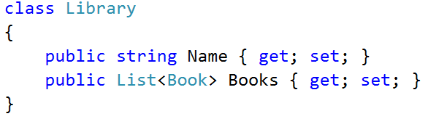
* **Create** an object of type Library.
* **Read the input** and create a Bookobject for each book in the input.
* Create a **LINQ** query that will **sum the prices by author**, **order the results** as requested.
* **Print** the results.

## Book Library Modification

Use the classes from the previous problem and make a program that **read a list of books** and **print all titles** **released after given date** ordered **by date** and then **by** **title lexicographically**. The date is given if format “**day-month-year**” at the last line in the input.

### Examples

|  |  |
| --- | --- |
| **Input** | **Output** |
| 5  LOTR Tolkien GeorgeAllen 29.07.1954 0395082999 30.00  Hobbit Tolkien GeorgeAll 21.09.1937 0395082888 10.25  HP1 JKRowling Bloomsbury 26.06.1997 0395082777 15.50  HP7 JKRowling Bloomsbury 21.07.2007 0395082666 20.00  AC OBowden PenguinBooks 20.11.2009 0395082555 14.00  30.07.1954 | HP1 -> 26.06.1997  HP7 -> 21.07.2007  AC -> 20.11.2009 |

## ** Student Groups

At the Software University we often organize programming courses for beginners in different towns. We usually run a **registration form** and after the registration finishes, we distribute the **students** into **study groups**. Groups have different sizes in each town.

You are given a report holding the **registrations for each town** and the **lab capacity** (seats count) for each town. It comes in the following format:

* **Town name** => **X** seats (where **X** is the capacity of the training lab in this town).
  + **Student name** | **student email** | **registration** **date** (in format day-month-year). The month name is given as 3 letters in English, e.g. “May”, “Aug” or “Nov”.
  + The next student come after the first, etc.
* Then the next town and its students come, etc.
* The input ends by a line holding “**End**”.

The **input** comes in the following structure:

|  |
| --- |
| Town1 => X seats  Student1 Name | student1_email@somewhere.com | day-month-year  Student2 Name | student2_email@somewhere.com | day-month-year  Student3 Name | student3_email@somewhere.com | day-month-year  …  Town2 => X seats  Student1 Name | student1_email@somewhere.com | day-month-year  Student2 Name | student2_email@somewhere.com | day-month-year  …  End |

Your task is to **create** and **print the study groups** for each town as follows:

* For **each town** create and print one or several **study groups** (depends of the number or registered students and the capacity of the lab in this town).
* For each town **order the students** by registration date (ascending), then by name (ascending) then by email (ascending), then fill them into groups. If the students are less or equal to the lab capacity, create only one group. When the students are more than the lab capacity, distribute them in multiple groups.
* Print all **groups ordered by town** (ascending) in the following format:
  + **Created G groups and T towns:**
  + **Town1 => email1, email2, …**
  + **Town1 => email1, email2, …**
  + …
  + **Town2 => email1, email2, …**
  + …

### Examples

|  |
| --- |
| **Input** |
| **Plovdiv** => **5** seats  Ani Kirilova |ani88@abv.bg |27-May-2016  Todor Nikolov | tod92@mente.org | 28-May-2016  Kiril Stoyanov | kirtak@gmail.com | 27-May-2016  Stefka Petrova | st96@abv.bg | 26-May-2016  Ani Kirilova | ani.k@yahoo.co.uk | 27-May-2016  Ivan Ivanov | ivan.i.ivanov@gmail.com| 27-May-2016  **Veliko Tarnovo** => **3** seats  Petya Stoyanova | stoyanova_p@abv.bg | 27-May-2016  Stoyan Kirilov | 100yan@gmail.com | 24-May-2016  Didi Miteva | miteva_d@yahoo.co.uk | 28-May-2016  Kiril Nikolov | kiro@kiro.net | 25-May-2016  Ivan Stefanov | ivan.stef86@gmail.com | 27-May-2016  Maria Kirova | maria.k@abv.bg | 26-May-2016  **Varna** => **2** seats  Ivan Ivanov | ivan.ivanov96@gmail.com| 29-May-2016  Stoyan Petrov | sto.sto.sto@gmail.com | 27-May-2016  Ivan Ivanov | vankata@mail.bg | 1-Jun-2016  Kiril Anev | anev_k@yahoo.co.uk | 27-May-2016  Ivan Ivanov | vanyo98@abv.bg | 29-May-2016  Petya Vladimirova|pete98@abv.bg | 20-May-2016  Ivan Ivanov | ivan.94.ivan@gmail.com | 29-May-2016  **End** |
| **Output** |
| Created **8** groups in **3** towns:  Plovdiv => st96@abv.bg, ani.k@yahoo.co.uk, ani88@abv.bg, ivan.i.ivanov@gmail.com, kirtak@gmail.com  Plovdiv => tod92@mente.org  Varna => pete98@abv.bg, anev_k@yahoo.co.uk  Varna => sto.sto.sto@gmail.com, ivan.94.ivan@gmail.com  Varna => ivan.ivanov96@gmail.com, vanyo98@abv.bg  Varna => vankata@mail.bg  Veliko Tarnovo => 100yan@gmail.com, kiro@kiro.net, maria.k@abv.bg  Veliko Tarnovo => ivan.stef86@gmail.com, stoyanova_p@abv.bg, miteva_d@yahoo.co.uk |
| **Comments** |
| **Plovdiv (group 1 – 5/5 students)**  Stefka Petrova | st96@abv.bg | 26-May-2016  Ani Kirilova | ani.k@yahoo.co.uk | 27-May-2016  Ani Kirilova | ani88@abv.bg | 27-May-2016  Ivan Ivanov | ivan.i.ivanov@gmail.com | 27-May-2016  Kiril Stoyanov | kirtak@gmail.com | 27-May-2016  **Plovdiv (group 2 – 1/5 students)**  Todor Nikolov | tod92@mente.org | 28-May-2016  **Varna (group 1 – 2/2 students)**  Petya Vladimirova | pete98@abv.bg | 20-May-2016  Kiril Anev | anev_k@yahoo.co.uk | 27-May-2016  **Varna (group 2 – 2/2 students)**  Stoyan Petrov | sto.sto.sto@gmail.com | 27-May-2016  Ivan Ivanov | ivan.94.ivan@gmail.com | 29-May-2016  **Varna (group 3 – 2/2 students)**  Ivan Ivanov | ivan.ivanov96@gmail.com | 29-May-2016  Ivan Ivanov | vanyo98@abv.bg | 29-May-2016  **Varna (group 4 – 1/2 students)**  Ivan Ivanov | vankata@mail.bg | 1-Jun-2016  **Veliko Tarnovo (group 1 – 3/3 students)**  Stoyan Kirilov | 100yan@gmail.com | 24-May-2016  Kiril Nikolov | kiro@kiro.net | 25-May-2016  Maria Kirova | maria.k@abv.bg | 26-May-2016  **Veliko Tarnovo (group 2 – 3/3 students)**  Ivan Stefanov | ivan.stef86@gmail.com | 27-May-2016  Petya Stoyanova | stoyanova_p@abv.bg | 27-May-2016  Didi Miteva | miteva_d@yahoo.co.uk | 28-May-2016 |

### Hints

First, create the **classes** to hold the **students**, **towns** and **groups**.

#### Creating Classes Student, Town and Group

The class Student will hold the information about a student: name, email and date of registration.

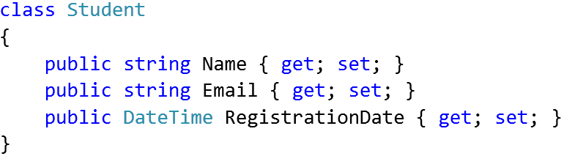

The class Town will hold the information about a town holding a list of registered students.

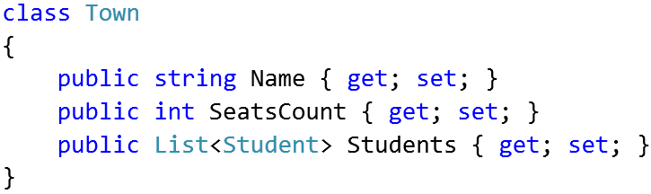

The class Groups will hold the information about a group holding a subset of the students for certain town.

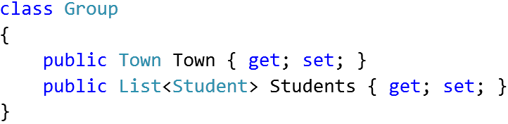

#### Read the Input

The next step is to **read and parse the input** to list of towns, each holding a list of students. Write a method to read the input from the console:

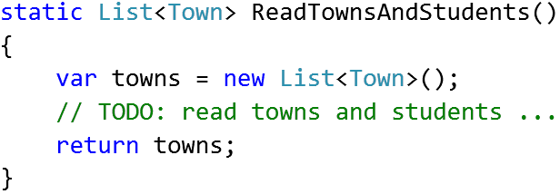

In a loop, read a text line inputLine from the console, until “**End**” is reached.

For each input line check whether the input line contains “**=>**”.

* If yes 🡪 inputLine holds a **town**, e.g. “Plovdiv => 5 seats”.
  + Create a new Town object.
  + Parse the town **name** and **seats count** from the input line and put them in the town.
  + Assign an empty student list for the new town:  
    town.Students = new List<Student>().
  + Add the new town to the list of towns.
* If no 🡪 inputLine holds a **student**, e.g. “Ani Kirilova | ani.k@yahoo.co.uk | 27-May-2016”.
  + Create a new Student object.
  + Parse the student **name**, **email** and **date** from the input line and put them in the student.
  + Append the new student to the list of students for the last town in the towns list.

#### Distribute the Students into Groups

Now, solve the essential part of the problem: for each town, create **one or several groups** and distribute the students between them.

Start from an empty method that takes as **input** a **list of towns** and produces as **output** a **list of groups**:

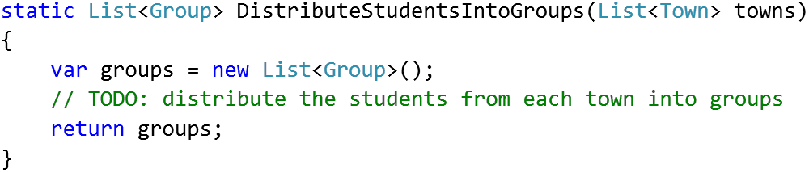

How to distribute the students?

In a **loop** go through the **towns, sorted by name**.

* For each town **order the students** by registration date, name and email.
* For each town put the first Town.SeatsCount students in the first group, the next Town.SeatsCount students in the second group, etc.

You may use code like this or write it yourself:

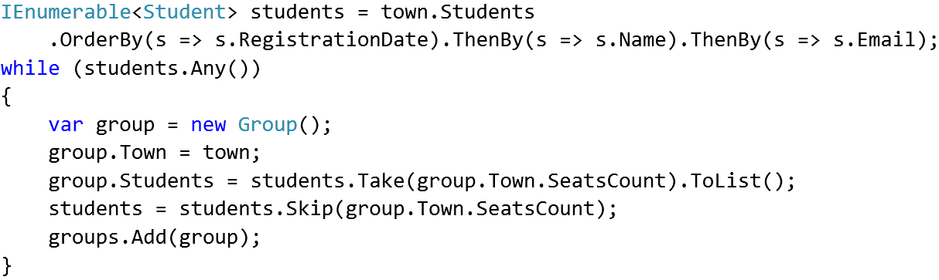

#### Print the Groups

Once the students are distributed into groups, **printing the output** is the easiest part of this problem.

* Print the **total count of groups** and total **count of towns** (distinct town names).
* Loop through the **groups, sorted by town name**.
* For each group **print** its **name** and the **emails** of its students, joined by “, ”.